The Digital

Dictionary

By

The Core Programmers

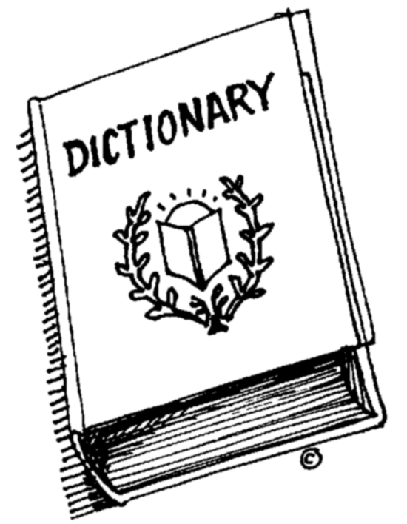

**Designed with C Programming**

**language.**

**Magical**

**Experience**

* **User friendly.**
* **Search by keywords.**
* **Efficient for the learners.**